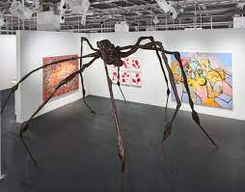
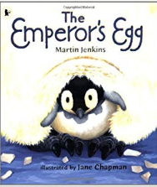
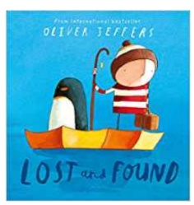
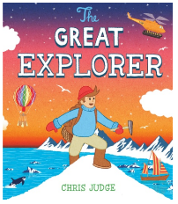
English
Non-chronological report
-Children will write a simple Non-chronological report with a series of sentences to describe aspects of the subject.
We will be reading ‘The Emperor’s Egg;’ which is a non-fiction book about emperor penguins. We will then be writing a report using a title, subheading, diagrams and labels.
We will also be writing a recount letter, based on our class read, The Great Explorer by Chris Judge

Science

Animals including humans:
-Identify, name, draw and label the basic parts of the human body and say which part of the body is associated with each sense.
We will then link our knowledge of sense to Polar animals and learn about their ‘super’ senses.

Seasonal change
-Observe changes across the four seasons.
-Observe and describe weather associated with the seasons and how day length varies.
During Forest School lesson, we will observe the changes in the environment from last term to this term. We will also look at how season effect the Polar regions.

Ice Kingdom

DT
Children will learn about sliding mechanisms and how to make a slider game.
-To use a range of materials creatively to design and make products.
-To use drawing, painting and sculpture to develop and share their ideas, experiences and imagination.
-To develop a wide range of art and design techniques in using colour, pattern, texture, line, shape, form and space.

Year: 1 Term: Spring 1
Geography
Why is it colder the further I get from the equator and how does the Arctic compare to Hertford?
Skills and Fieldwork
-Use world maps, atlases and globes.
-Use aerial photos, construct simple maps.
The children will be able to locate the equator, North Pole and South Pole are on a globe. They will know what it is like there; weather, animals, and landscape. They will be able to label aerial photos of the artic with physical and human features saying what they are. Children will discuss hot and cold places and compare the Arctic to their home location.
Discrete subjects
Maths: Comparison of quantities and part–whole relationships and Numbers 0 to 5.
RE: Branch 3 – Galilee to Jerusalem
PE: Gymnastics.
RSE: Unit 3 –emotional well-being.
Phonics: Phase 5.
Computing: Lego builders.

