English
Retelling a traditional Tale – Jack and the Bean Stalk.
-Focusing on using phonics to write a series of full sentences independently. Children will use actions and orally retell the story of Jack and the Beanstalk before creating their own written version of the story.
Non-Fiction - instructions.
-Children will learn the features of instructions, focusing on verbs. They will then use this knowledge to write a set of simple instructions to plant a seed.

Art
This half term we will be learning about mark making, experimenting with media and drawing from observation. We will evaluate art with an understanding how art can be varied and made in different ways and by different people.

We will produce a drawing of an object in the classroom that displays observational skill, experimenting with a range of lines and mark making.

Science

Plants
-Children will learn to identify and name a variety of common wild and garden plants, including deciduous and evergreen trees.
- Children will learn to identify and describe the basic structure of a variety of common flowering plants, including trees.

We will be spending time at Forest School where we will be planting our own flowers and vegetables and observing them as they grow. We will also be able to go on plant hunts which will help us to learn their names as well as observing their structure.

Discrete subjects
Maths: shapes, additive structures, numbers 0-10.
RE: Special meals and Change (Lent and Easter.)
PE: Attack, defend and shoot.
Phonic: Concentrating on Phase 5 alternative sounds. Both with real words and alien words.
Year: 1 Term: Spring 2
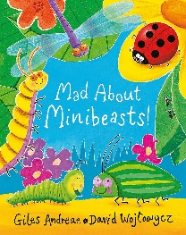
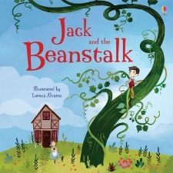
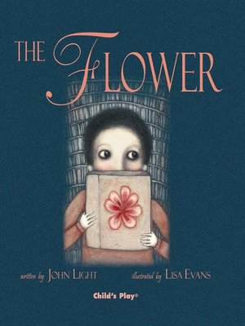
Geography
My school grounds
This half term the children will be learn about our own school locality. We will be learning:
-where we are located in the UK.
-the human and physical features in our school environment.
-the daily weather in our area.
-to use maps, aerial photos and directions for our school grounds.

Enchanted Woodland

Wow starters: Children to watch a time lapse of a growing plants and a busy garden. What is happening? What do you know? What would you like to find out more about?
Outcome: Children will be able to successfully grow their own plants and talk passionately about how to grow and look after them.
Celebration: Parent will be invited to come into school and take part in a Forest School session with the children so that they can demonstrate what they have learnt this half term.
Key questions: What are the parts of a plant? How do you look after a plant? What traditional tale character might we meet in an enchanted woodland?

