Can
Must
  Reading  Read 15 minutes every day with your adult.  Listen to stories read by others. |   Maths  2Dos on purple mash – set every Friday.  Practice 2, 5 and 10 times tables. Practice saying 1 times 2 is 2, 2 times 2 is 4…. Then see if you can answer when they are not in order.  We have done these songs is class:  https://tinyurl.com/4fehm6mf - 2  https://tinyurl.com/43jar3za - 5  https://tinyurl.com/mt353fxm - 10 |   Spelling – Challenges  Work on your spelling bronze, silver and gold. Remember to bring them in to be tested as soon as you’re done.  Aim to complete a level over this half term.
RE –  Build an Easter story box. Choose a part of the Easter story, for example you could choose Palm Sunday. Find a box, it could be a shoe box or cereal box. Start with the background, then make the characters and add any details that you want to include. You could then use your story box to help you retell the Easter story.  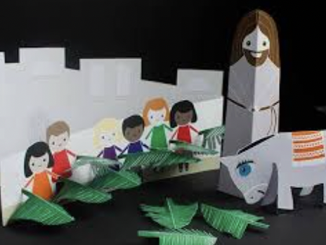 | Year 2  Spring 1  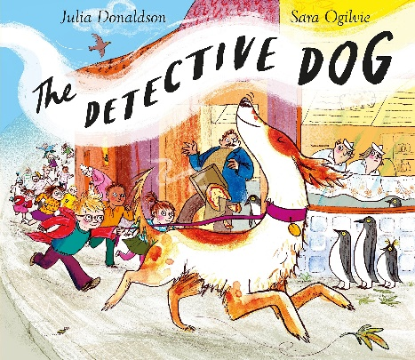  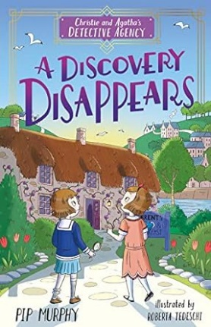  Street Detectives | 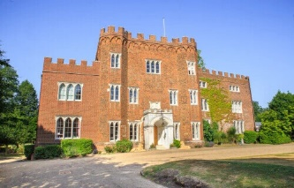  History – Hertford castle  Create Hertford castle in your own way – it could be how it looks now or how it looked in the past.  You could:  -Create a model of it using a shoe box, junk modelling, Lego, plasticine etc.  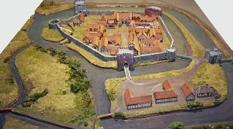  - draw it, maybe you could draw it from a bids-eye view.  -label the parts or write some labels with facts about the castle.
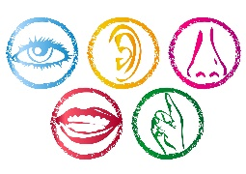  English – senses description  Use your sense to decribe a setting – can we guess where you are?  Example:  I can see the marvellous monkeys swinging in the trees.  I can feel the soft fur of the rabbits.  I can hear the loud roar of the lions.  I can smell the pongy poo from the elephants.  I can taste some delicious ice-cream.  Where am I? - The Zoo | Art  Create a simple map Hertford, include a few key features like St Joseph’s School, your home, the library. Be as creative as you can. You could draw, paint, use interesting materials or make it 3D.   | 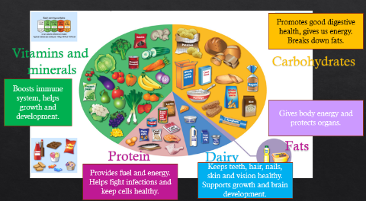  Science – balanced diet  Draw a plate of your favourite dinner or write a menu of your favourite meal. Then check it is a balanced diet and has all the food groups by labelling your plate or menu – add in anything you have missed.

